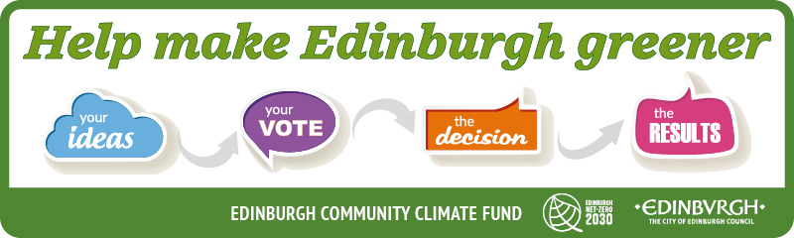
The Edinburgh Community Climate Fund has been set up to support community-led climate change projects. It uses a process called participatory budgeting to enable citizens to decide how to spend £100,000 that will support the delivery of the Edinburgh Climate Strategy.
More information can be found online.
What can you apply for?
We need your ideas for projects that will meet one or more of the following objectives:
- Create opportunities for community leadership and learning on climate change
- Reduce greenhouse gas emissions within communities and contribute to the net-zero target for Edinburgh
- Generate sustainable projects for the benefit of local people to build resilience or adapt to climate change within communities
- Build relationships between neighbourhoods of different socio-economic and ethnic backgrounds to work together on just, equitable and accessible climate and resilience activities contributing to the city’s net zero target, also ensuring that activities work towards reducing or removing barriers for disabled people in the transition to net zero.
Who can apply?
Any Edinburgh-based community, voluntary or non-profit organisation can apply for up to £20,000 to put ideas into action. Normally these organisations will have one of the following structures:
- Constituted community group or club
- Social Enterprise
- Community interest companies (CIC)
- Registered charity (SCIO)

Informal groups who do not meet the above criteria can still apply but will be required to work with a parent organisation who would submit the application in partnership. If you are not sure or would like to discuss please contact:

communityplanning@edinburgh.gov.uk
How do you apply?
To apply for the funding you must return this form before midnight on 12th February and submit an idea proposal through the Your Voice platform. If your idea fits with the fund’s objectives, the community will get to vote for the best idea at the start of March.

(1a) Organisation/group name:

(1b) Project name:

(2) Tell us about your organisation / group (what do you do?) (150 words maximum)

(3a) Please select the fund criteria which your project relates to (Select all that apply)
☐Create opportunities for community leadership and learning on climate change
☐Reduce greenhouse gas emissions within communities and contribute to the net-zero target for Edinburgh
☐Generate sustainable projects for the benefit of local people to build resilience or adapt to climate change within communities
☐Build relationships between neighbourhoods of different socio-economic and ethnic backgrounds to work together on just, equitable and accessible climate and resilience activities contributing to the cities net zero agenda, also ensuring that activities work towards reducing or removing barriers for disabled people in the transition to net zero.

(3b) Tell us about the project you would use the money for. (500 words maximum)

(4) Describe your project in no more than 30 words (this will be used for publicity)
(5a) Who do you hope will benefit from this project?

(5b) Is your group open to all?
☐Yes | ☐No
If no, please explain:

(5c) Will the project have a positive impact on any of the following protected characteristics?

☐Disability | ☐Marriage or civil partnership | ☐Pregnancy and maternity | ☐Race
☐Sex | ☐Age | ☐Sexual orientation | ☐Religion or belief
☐Gender reassignment

(6) Where will the project be delivered?

(8) How many people do you hope will benefit from your project?

(7) Project start date:
Project end date:

(9) Is anyone else working with you on the project?
☐Yes | ☐No
If yes, please tell us about this:

(10) Do you require permission from anyone or any additional insurance to carry out your project?
☐Yes | ☐No
If yes, please tell us about this:

(11) Please outline a breakdown of the cost of delivering this project (including VAT). |  | (12) Do you have additional funding or income from charges which will contribute to this project? If yes, please detail below
Goods/Equipment/Time etc | £ | Source | £
Total Expenditure |  | Total income

Section 2: For office use only – the information in this section will NOT be publicised

Contact person:

Address (including post code):

Telephone number:

Email address:

Please give details of your group’s bank account: (account must be in name of the group applying)
Name of bank
Bank address
Account name
Bank sort code
Account number

DECLARATION

All applications must be signed by two people who are recognised as representatives of your organisation. One of these people MUST be a board/management committee member.

You are being asked to declare that;

- You will comply with all relevant funding conditions;
- To the best of your knowledge, the information contained in this application and any accompanying attachments is accurate.

Electronic Signature……………………..Electronic Signature……………………………

Name………………………………………Name……………………………………………

Date………………………………………..Date……………………………………………

Position……………………………………Position…………………………………………

Please return this form and any associated documentation to:

Email: communityplanning@edinburgh.gov.uk

 | Document Checklist
☐ | Completed Application
☐ | Your constitution or that of your supporting organisation
☐ | Details of any estimates/quotations obtained for goods/services (If appropriate)
☐ | Submitted a project/idea proposal online with a photo

